**42.ALV_GRID_Interactive 1(user double clicks) Output**

Run the report in se38.Below is the Selection screen .Give a suitable CARRID and Execute.

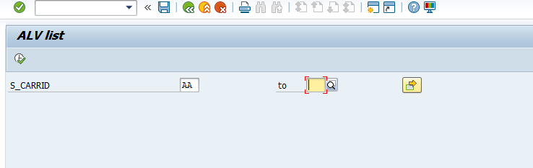

The expected output is as follows . Double click on any record.

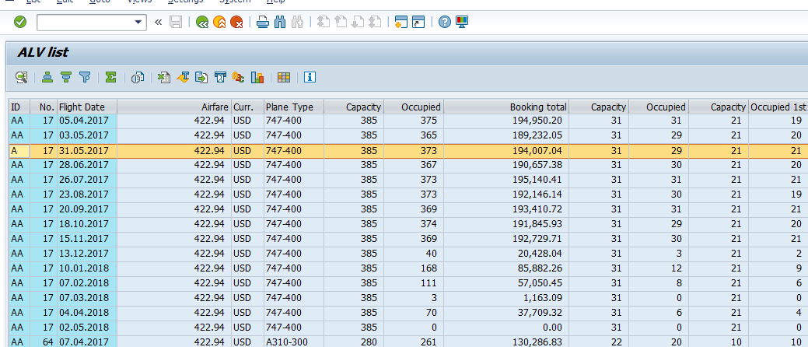

The secondary list with the below output opens up.

